**Life Skills Art with Ms. Campbell**

**Assignment #1: Found Object Color Wheel**

Using objects that you find around your home, you are going to create a color wheel.

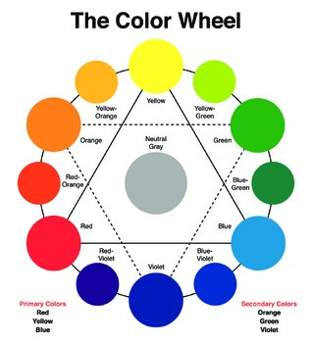

**Step 1-**You need **5 objects in each color** - Red, Orange, Yellow, Green, Blue, Violet.

**STEP 2-**Once you’ve collected your objects, arrange them in a wheel.

They need to be arranged in the correct color order! Red, Orange, Yellow, Green, Blue, Violet.

**STEP 3-** Take a photo of your color wheel and send to [NCampbell@nfschools.net](mailto:NCampbell@nfschools.net)

*TIP- get the camera phone right over top of your color wheel to take the photo.**

If you google **“Found Object Color Wheel”** or look at *#foundobjectcolorwheel* on Instagram, you will find lots of examples.

**TIPS:**

* Find at least 5 objects for each color.
* After you arrange your wheel, take a step back and make sure it looks the way you’d like it to.
* Add more objects if one color seems small.
* Have fun and bring it things that show off who you are!

BE SURE TO INCLUDE YOUR NAME IN THE EMAIL

EXAMPLES:

 